HSV Großmittel/ Sektion OL
p.A.: Klaus Holzinger, Ungerfeldgasse 4a, 2540 BAD VÖSLAU
klaus.holzinger@gmx.net
Invitation and Information
Austrian Championship Sprint
1.Austrian-, 1. Slovakian- and 3. Hungarian- Cup 2015 Sprint
WRE in Mountainbike- Orienteering Sprint
Blumau- Neurißhof, 25. April 2015,
16.30081 E, 47.92974 N
Hostfederation Austrian Orienteering Federation
Eventmanager Klaus Holzinger
Courseplaner Klaus Kramer
Technical advisor Thomas Wieser
Organiser HSV Großmittel/ Sektion OL
Event center,+ Soccerfield Neurißhof (ASK Blumau),
Meeting Point Road L 4041, 00:30 pm (12:30);
Format Sprint distance
Terrain Military training area, flat and partly open terrain, dense forest with many ruins and meadows. You can bike everywhere and are allowed to leave the tracks but take care of prohibited areas
It is strictly forbidden to cross the river Piesting!

Streckenlängen Kategorie Länge (Luftlinie) Posten
H 21 E 6,6 km 23
D 21 E, H 40-, H20 5,6 km 20
D 40-, D -20 4,3 km 14
H 50-, H -17 4,6 km 17
D 50-, D -17, D 21- K 4,2 km 14
H 21- K, Direkt/Offen 4,4 km 14
D 60-, H70- 3,6 km 12
H 60- 3,9 km 12
H/D -14 3,8 km 14
Familie, Neulinge 3,8 km 13

First start 2:00 pm (14:00)
Way to Start 1,4 km marked with white/red ribbon; warmup on the way to start
Startmodus according to the startlist
The categories family/newcomers, Direct/Open can start between 14:30 and 15:45 (free starting time)
Map Scale 1: 7.500, 2m interval; 3/2015
M 21- Elite/ WRE have a mapchange at control 14. There you continue on the back side of your map!!
Finish is closed 17:00
Read out Si- chip direct after the finish
Punchingsystem/ SPORTident
Timekeeping SportIdent; if a SI- controlstation is out of order you must punch with the controlpincers
Price giving 5:00 pm (17:00)

Startlist available at Thursday 23 04 2015 www.oefol.at
Information klaus.holzinger@gmx.net; www.oefol.at

Important notes:
- Wearing of helmet is compulsory
- Obey the rules of the road traffic act
- Competitors take part at their own risk and are responsible for their own safety
- Rules valied for World Ranking: IOF MTBO Competition Rules (1.1.2015) http://orienteering.org/mtb-orienteering/rules/
- Registration for IOF World Ranking only with IOF Eventor (!) http://eventor.orienteering.org/ - Deadline: 15.04.2015
- Accomodation: http://www.badvoeslau.at/, www.motel-verde.at , near the competitionareas of both days
- WC only at the competitioncenter
- It is forbidden to bike on the soccerfield
- Snacks are available at the competition center
- Allways keep RIGHT and take care of other competitors and people in the forest
- You will have high speed in the flat area, take special care at crossings!

The event manager: Klaus Holzinger, m.p.

Special symbols – ridable tunel (gray V)
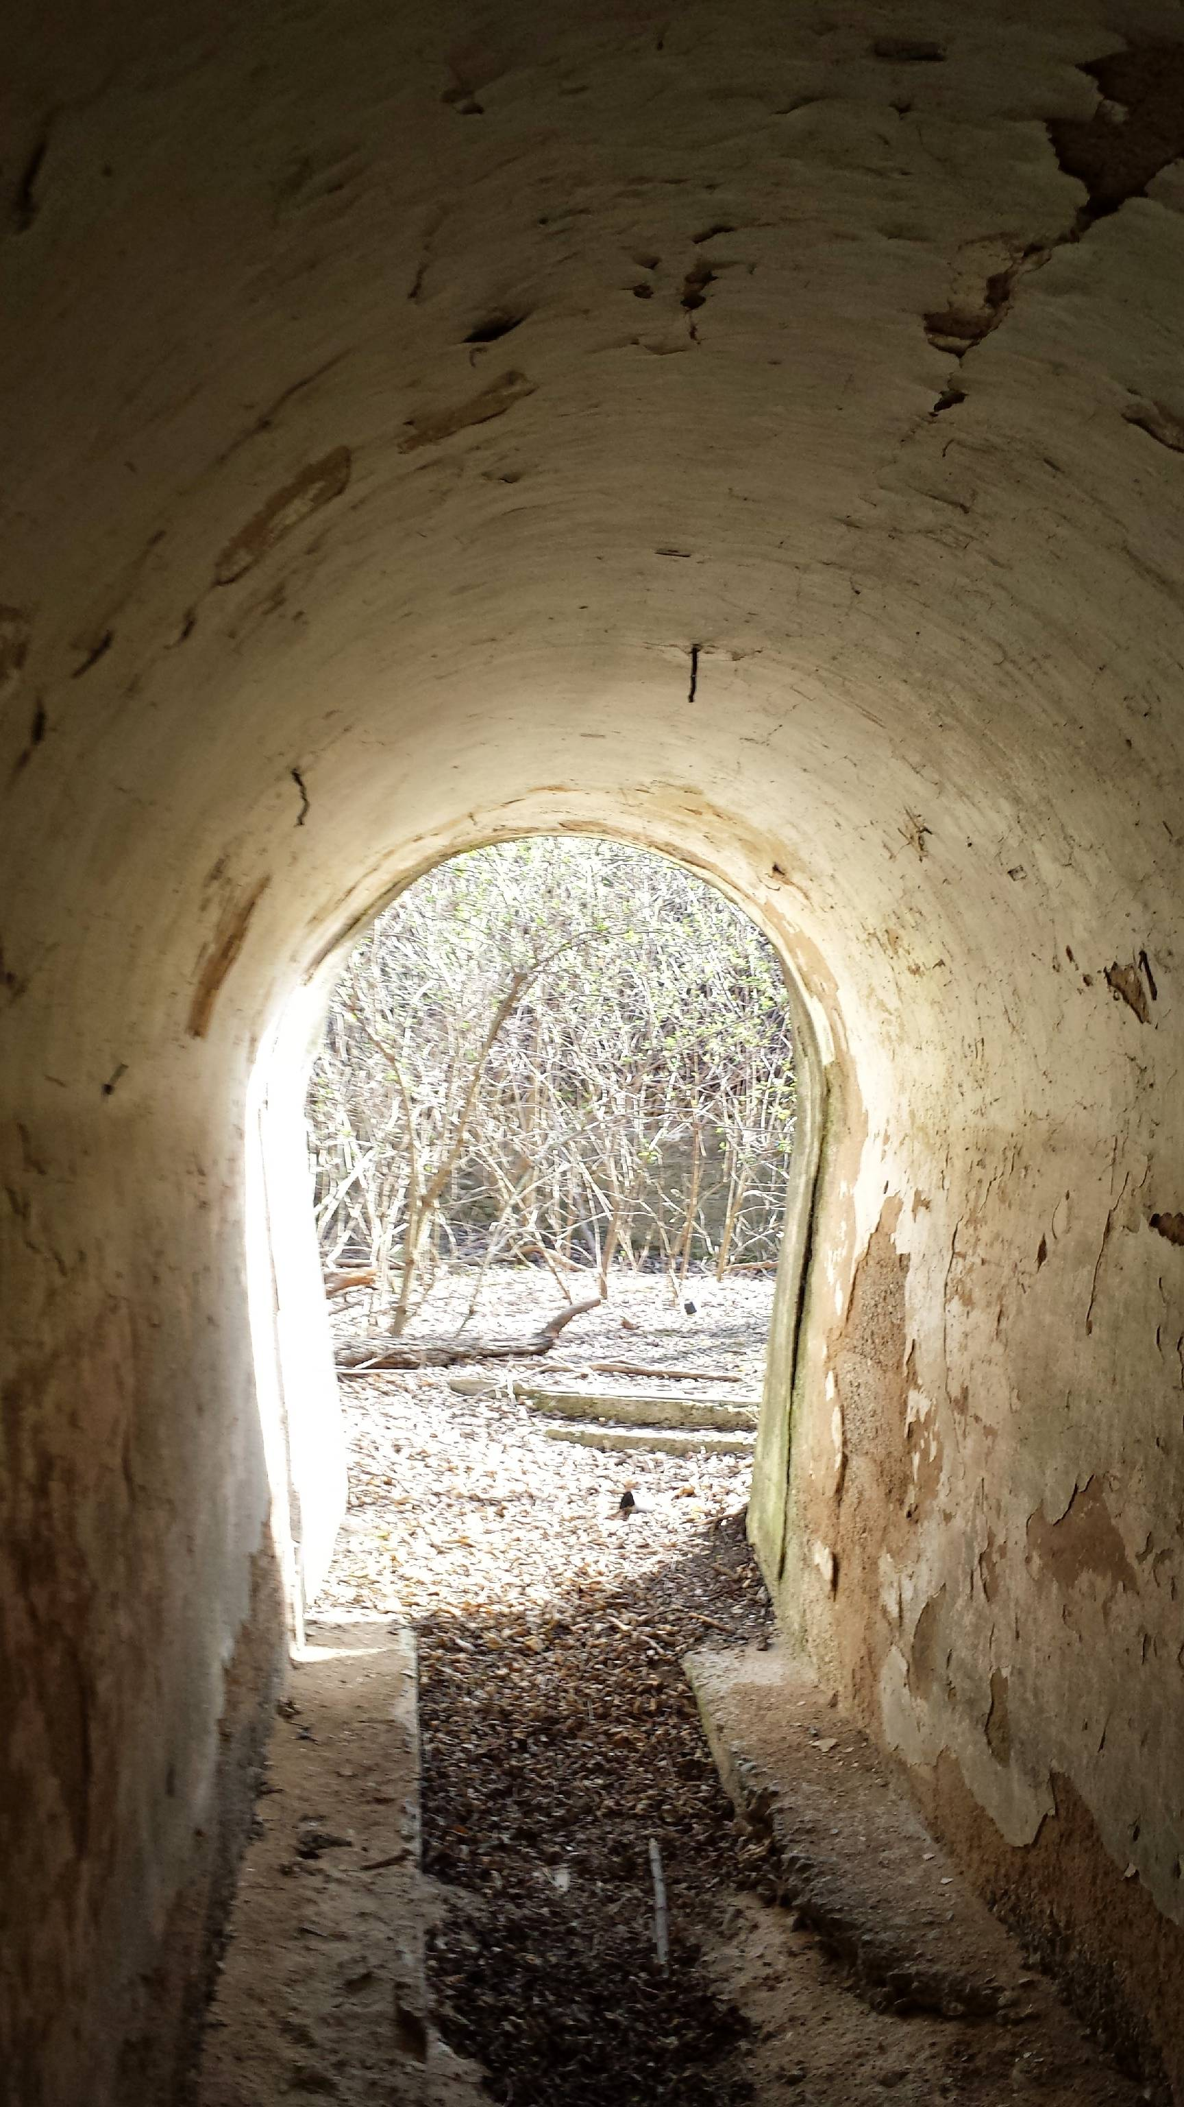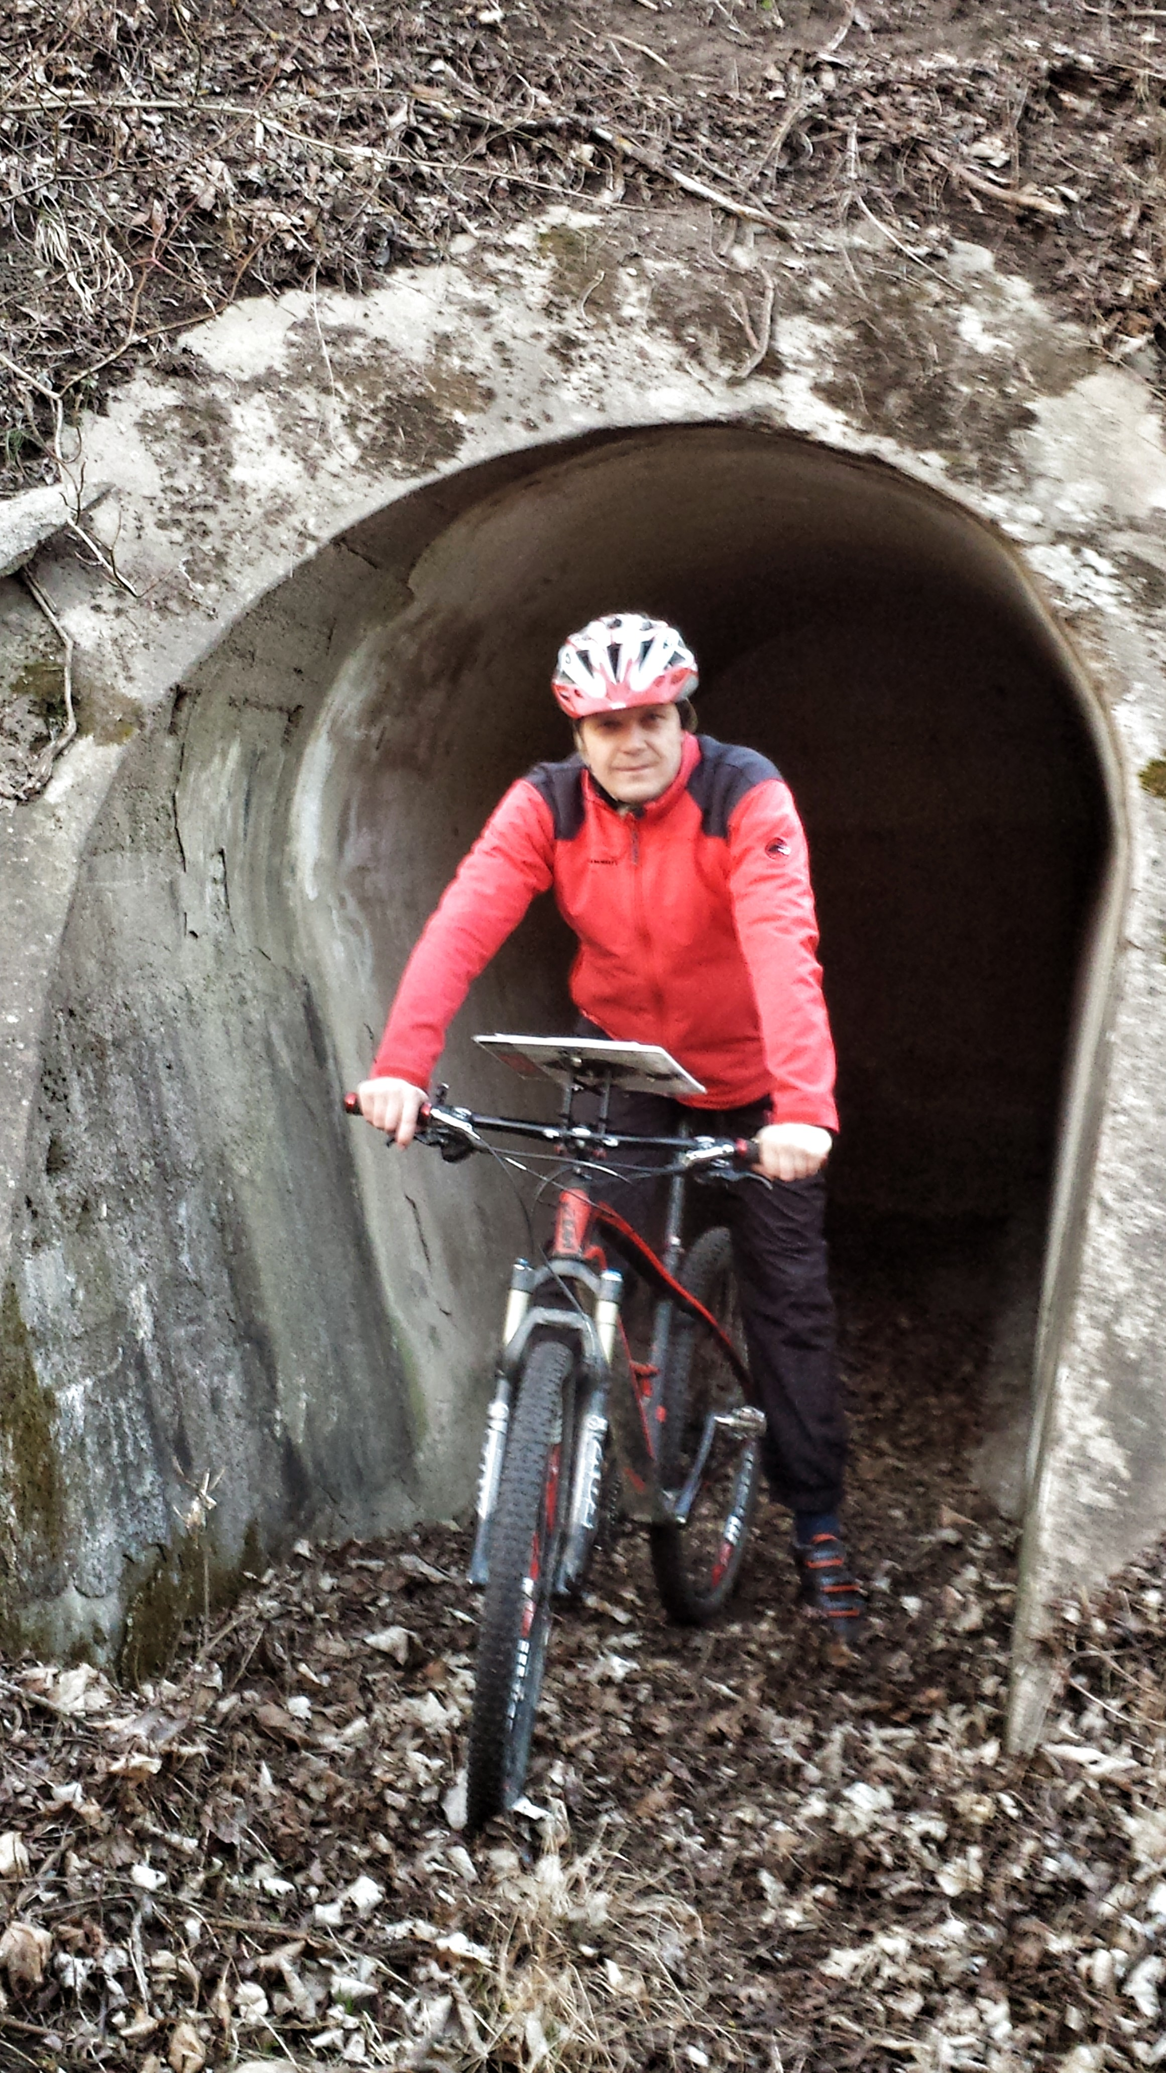

In a similar way you can also cross old houses!

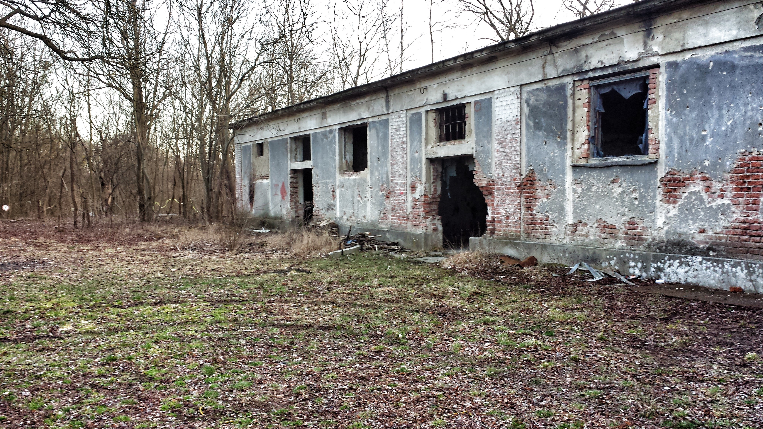

Dangerous river – you are not allowed to cross this river without a bridge

Otherwise wie will have to disqualify
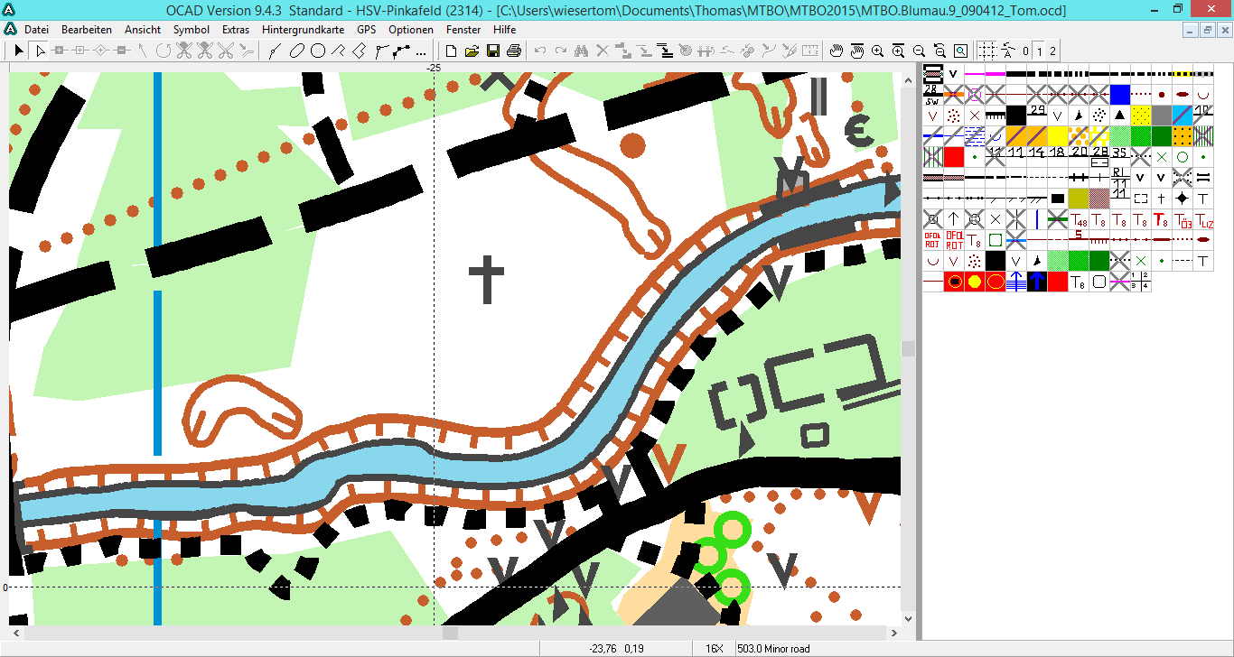

There are a number of bad visible tracks in the forest but you can bike there on a good ground speed.

Map of the competitoncenter

